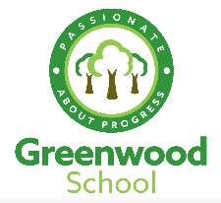
Subject: Art year11
Year: 2023
Term: spring2
2

Greenwood School Curriculum Summary

episode name | episode outline | Online link(s) | Other Resources
Exam paper | Complete a mind map of thoughts and ideas | https://www.bbc.co.uk/bitesize/guides/z2hp3k7/video  https://www.bbc.co.uk/bitesize/guides/zwk82nb/revision/1
Research 1 | AO1 Research – collage inspiring images and research 2 artists |  | https://classroom.thenational.academy/lessons/skills-and-development-part-3-6tk3gc?activity=video&step=2
Research 2 | AO1 Research – your version of an artists work | https://www.bbc.co.uk/bitesize/guides/zc7sfrd/revision/1 | https://classroom.thenational.academy/lessons/skills-and-development-part-1-68tp8c
Experiment 1 | AO2 Experiment – explore your idea with at least 2 media | https://www.bbc.co.uk/bitesize/guides/z8pfcj6/revision/1 | https://classroom.thenational.academy/lessons/painting-techniques-mark-making-crt3gr?activity=video&step=2
Experiment 2 | AO2 Experiment – repeat one of the pieces | https://www.bbc.co.uk/bitesize/guides/z8sv97h/revision/1
Record | AO3 Recording of journey – annotate sketch book | https://www.bbc.co.uk/bitesize/guides/zgtngdm/revision/1 | https://classroom.thenational.academy/lessons/presentation-cgrkcc?activity=video&step=1
Final piece | AO4 Complete final piece

